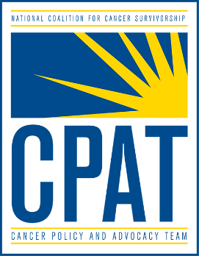
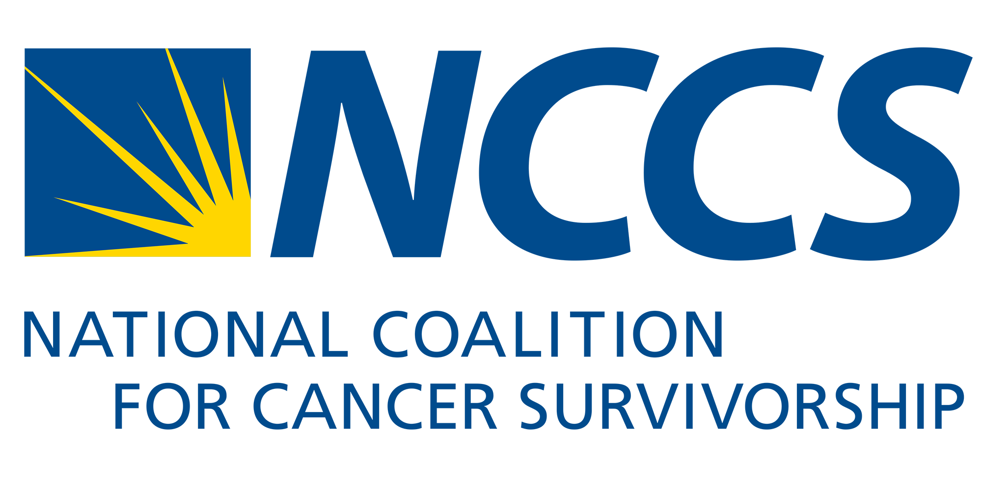

Cancer Care Planning and Communications Act
Telling Your Story: A Step-by-Step Worksheet

People have been telling stories since human beings first sat around campfires. We are hard-wired to take in new information through stories.

Statistics reach people in the head. Stories hit people in the heart. Sharing your personal experience is a powerful way to establish a connection and drive your listener to action. Your audience (e.g. elected officials, donors, the media, other volunteers) may disagree with your facts or arguments, but they cannot argue with your unique personal experience.
The steps below are based on research in effective storytelling, but you should tailor them to your own circumstances.

1. Hi. I’m [name] from [place].
If meeting with a Congress Member, identify yourself as living in their district.
________________________________________________________________________________________________________________________________________________________________________________________________________________________
________________________________________________________________________

2. My life changed when [describe your diagnosis or a loved one’s].
Example: It was confusing to get all this new information, all at once. I didn’t have time to ask questions about my treatment plan, let alone see it in writing.
Example: I didn’t have any context for all this overwhelming information. I didn’t know whether I should skip chemotherapy and go straight to radiation, one of several options.
________________________________________________________________________________________________________________________________________________________________________________________________________________________
________________________________________________________________________

3. It would have been easier if I had received a treatment plan from my cancer care team. This would have provided me with the information I needed to make decisions, play a larger role in coordinating all the elements of my care, and help me move from treatment to survivorship.
________________________________________________________________________________________________________________________________________________________________________________________________________________________

4. Providers would benefit from giving their patients treatment plans, as well. It would help ensure the patient is receiving the right care at the right time, treatment and management of symptoms is better coordinated, and cancer care resources are used effectively.
________________________________________________________________________________________________________________________________________________________________________________________________________________________
________________________________________________________________________

5. We needed cancer care planning before the COVID-19 pandemic, but now it’s urgent. The COVID-19 pandemic disrupted many people’s cancer treatment. Cancer patients found they needed a treatment plan to protect against disruptions in care, duplication of care, and gaps in the coordination of all the elements of care.
Example: One of my close friends delayed her surgery because she didn’t want to go into a hospital and risk exposure to COVID-19.
________________________________________________________________________________________________________________________________________________________________________________________________________________________
________________________________________________________________________

6. Can you help by [co-sponsoring] the Cancer Care Planning and Communications Act of 2021 (H.R. 4414)? It would allow Medicare beneficiaries to receive a cancer care plan.
________________________________________________________________________________________________________________________________________________________________________________________________________________________
________________________________________________________________________

*******
Next, practice telling your story. Time it and try to keep it under two minutes. Hang onto the details that are vivid and memorable. Omit the content that is unnecessary or distracting. Ask for feedback from friends and other volunteers. With practice, you will be able to shake your nervousness but keep your energy and passion.

